Congratulations on your new role!

As part of our philosophy to give back to the community, we organize an annual campaign to support United Way Peterborough & District. Although our United Way Campaign will take place this fall, you do have the opportunity to start giving now and your donation will be counted to our annual Campaign Goal!

Your donation will help to ensure 46,263 people in PTBO County will have access to the 275 vital programs and initiatives made possible through United Way funding. Together, we can go beyond helping one person at a time, to address the bigger issues that prevent individuals and families from building a better life – such as poverty, mental illness, isolation, education inequality or domestic violence.

As a new employee, we encourage you to consider making a contribution through a payroll deduction, allowing you to spread your donation out throughout the year. It’s so easy to make a difference in our community, for example:

$5/pay funds 25+nutritious meals to school age children or delivery of healthy meals to isolated seniors
$19/pay provides 5 nights of safe shelter to a youth or family in crisis
$50/pay helps a woman to access 4 weeks of wrap-around supports such as counselling, legal, immigration, housing, education and employment services

You can also contribute today with a one-time credit card donation.

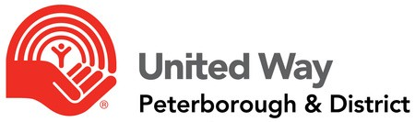
Please read the enclosed pledge form and information about United Way, and consider this opportunity to invest in our local community. Together, we can ensure that much-needed support reaches our friends and neighbours who need it the most.

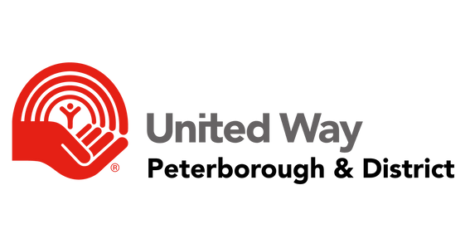Thank you,
United.
together we can...

<Name of Organization Executive>
<Position of Organization Executive>

Scan the QR to read our 2022-23 reports
IMPACT REPORT
ANNUAL REPORT

